MINI PROJECT

NAME: Parth Galhotra

REG NO : RA2111032010029

TITLE : C-Programming in Election system

AIM : To create a C program representing the election system where one can cast their vote on their favorite person

ABSTRACT :

This C program demonstrates the process of election system where one can add the party name ,cast their vote , check the vote count and find who is in leading position . It is used to elect candidates from the list made by adding the party details .This program contains basic header file , #include <stdio.h> and many more and uses several functions and data types . ‘do’ loops and ‘switch’ statements have been used so that the user could enter their opinion on the output screen . Structures have also been used. Overall the program is not complicated , and is useful in casting one’s vote on their favorite leader. A Database has been created where the votes are stored. The code can be executed in ‘DEVC++’ or any C-compilers .

ALGORITHM :

First we declare header file and then define the candidates name followed by declaring the return type (void in this case) , function name (retPcode, retVC, retName, Enter, Display, Cast Vote, Result) and printf statements , switch cases to print the options which is to be displayed on the output window. When coming to the ‘leading candidate’ section , We use if control statement and basic operators of file handling to find out which candidate has got more voting. We store the votecount and the party details in a binary file that we can access to perform operations and read it at our leisure. We can also update the records during the vote casting through this method by using seek() in file handling. So main function is created and below that we use ‘while’ loop to execute the program again in order to the option selected on the output window. ‘Switch’ statements have been used which tests the value of the given variable and compares it with multiple cases (Here we have got 3 cases). This program continues until the choice to continue the program becomes something other than ‘Y’ or ‘y’.This program is a simple menu-driven program with many options including the option to exit which helps the user to understand the methodology better.

PROGRAM :

#include <stdio.h>

#include <string.h>

#include <process.h>

struct party

{ char name[40] ;

int code, vc;} pt;

FILE *fp;

int retPcode()

{ return pt.code;}

int retVC()

{ return pt.vc;}

char* retName()

{ return pt.name;}

/* Write records into binary file */

void Enter()

{

char another = 'Y' ;

pt.vc=0;

fp = fopen ( "EVOTING.DAT", "a+b" ) ;

if ( fp == NULL )

puts ( "Cannot open file" ) ;

while ( another == 'Y' || another == 'y')

{

printf ( "\nEnter Political Party name and Party Code: " ) ;

scanf ( "%s %d", pt.name, &pt.code) ;

fwrite ( &pt, sizeof ( pt ), 1, fp ) ;

printf ( "Add another record (Y/N) " );

fflush ( stdin ) ;

another = getche( ) ;

}

fclose ( fp ) ;

}

/* Reads records from binary file and displays them on VDU */

void Display()

{

fp = fopen ( "EVOTING.DAT", "rb" ) ;

if ( fp == NULL )

puts ( "Cannot open file" ) ;

printf("\n Code \t Name \t Vote Count");

while ( fread ( &pt, sizeof ( pt ), 1, fp ) == 1 )

printf ( "\n %d \t %s \t %d", pt.code, pt.name, pt.vc ) ;

fclose ( fp ) ;

}

void CastVote()

{

int pv, cd, pos;

fp = fopen ( "EVOTING.DAT", "rb" ) ;

if ( fp == NULL )

puts ( "Cannot open file" ) ;

printf("\n Code \t Name");

while ( fread ( &pt, sizeof ( pt ), 1, fp ) == 1 )

printf ( "\n %d \t %s", pt.code, pt.name) ;

fclose ( fp ) ;

printf("\n ======== Cast your Vote ======= ");

printf("\n Enter the code for party: ");

scanf("%d", &cd);

fp = fopen("EVOTING.DAT","r+w");

while(fread(&pt,sizeof(pt), 1, fp) == 1)

{

if(retPcode()==cd)

{

pv=retVC();

pos=sizeof(pt);

pt.vc=pv+1;

fseek(fp,-pos,SEEK_CUR);

fwrite(&pt,sizeof(pt),1, fp);

break;

}

}

fclose(fp);

printf("\n Thanks for your vote......\n\n");

}

void Result()

{

int maxCode=0, maxVote=0;

char *n;

fp = fopen("EVOTING.DAT","r+w");

while(fread(&pt,sizeof(pt), 1, fp) == 1)

{

if(retVC()>maxVote)

{

maxVote=retVC();

strcpy(n, retName());

maxCode=retPcode();

}

}

fclose(fp);

printf("\n === Winner Party ===\n");

printf("\n\t%d-%s with %d Votes\n\n", maxCode, n, maxVote);

}

void main( )

{

int ch;

do

{

printf("\n =========== MENU ==========");

printf("\n 1. Enter Party Details ");

printf("\n 2. Display Party Details ");

printf("\n 3. Cast Vote ");

printf("\n 4. Results ");

printf("\n 0. Exit ");

printf("\n Enter your choice : ");

scanf("%d",&ch);

switch(ch)

{

case 1:

Enter(); break;

case 2:

Display(); break;

case 3:

CastVote(); break;

case 4:

Result(); break;

case 0:

exit(0);

}

}while(ch!=0);

}

OUTPUT :

1) Appearance of Output window :

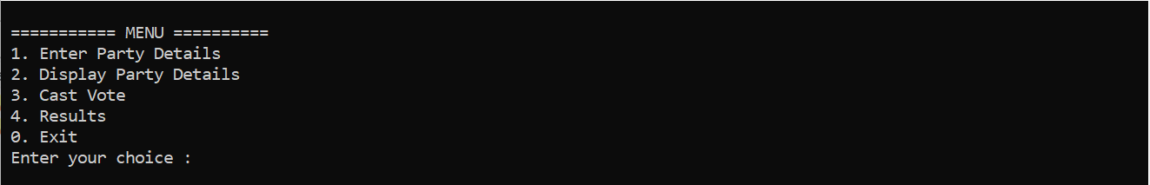

2) When Option 1 is selected :

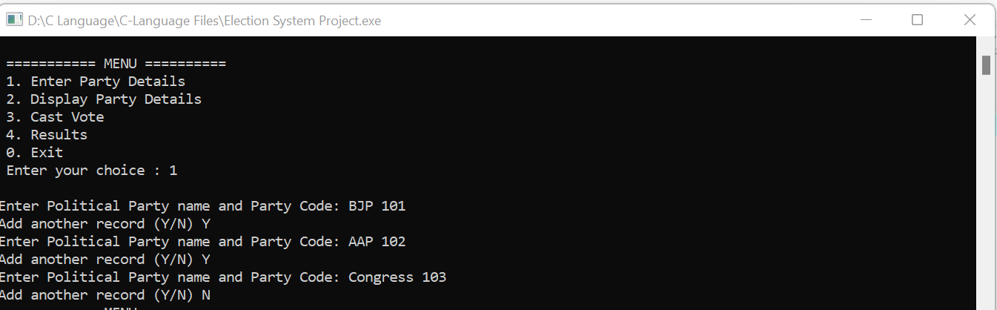

3) When option 2 is selected next :

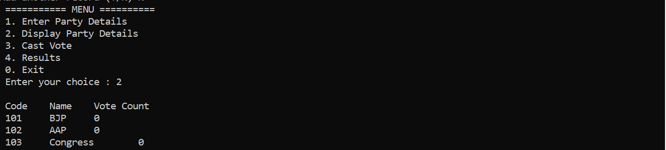

4) When option 3 is selected :

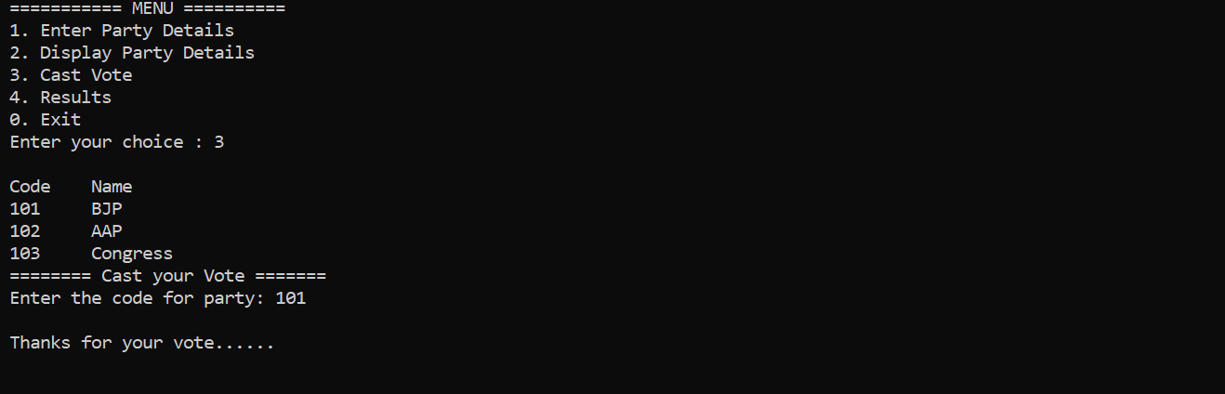

5) When option 4 is selected:

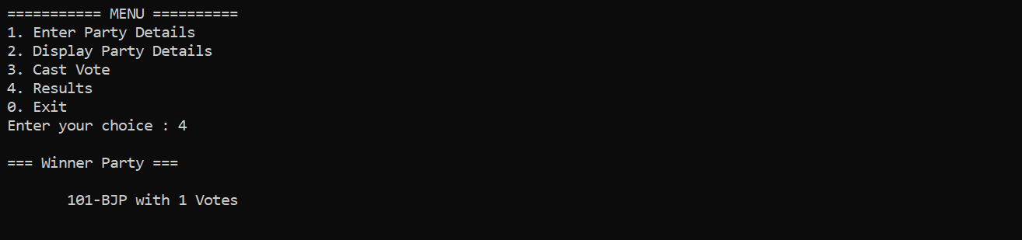

6) Termination of program when option 0 is selected :

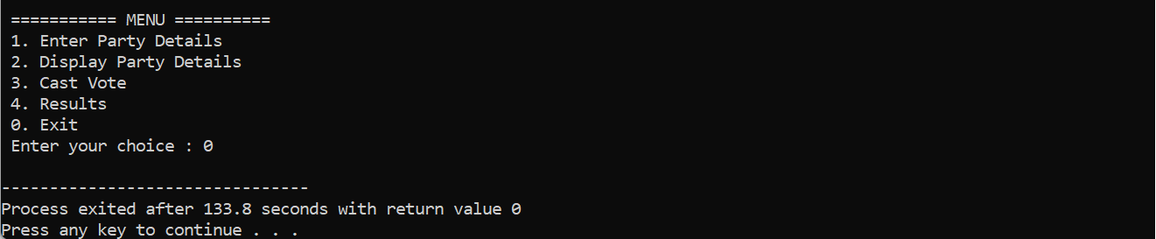

RESULT : Hence a C program to demonstrate voting system is created and executed in compiler to get desired output .

THANK YOU